Global Development Project
2024 Financial Accomplishments
A Year of Empowering
Women, Youth, and Children
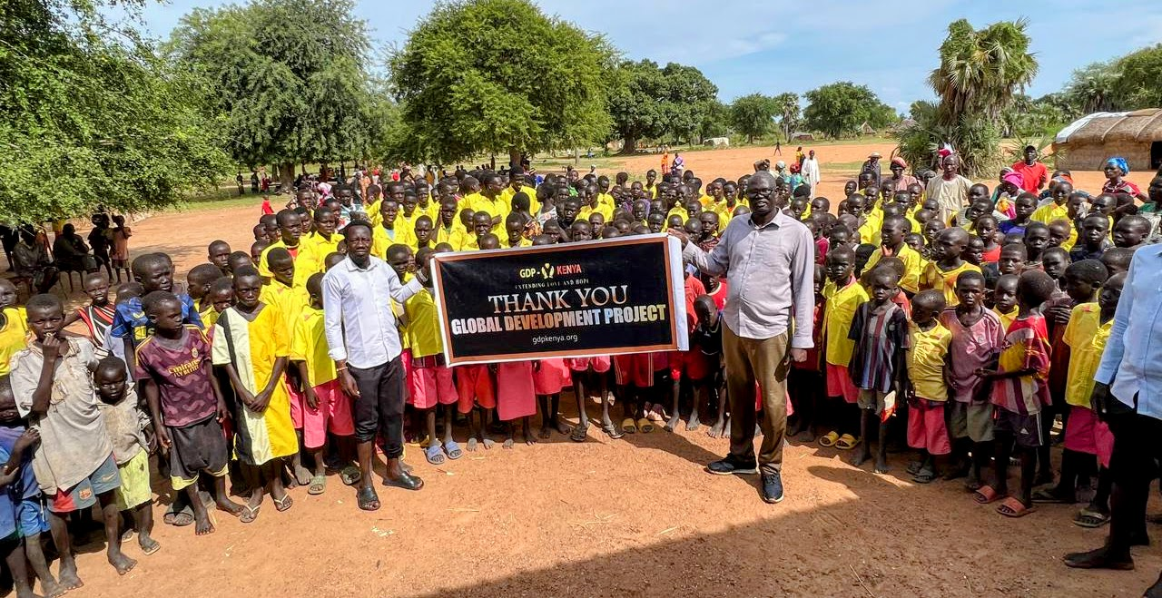

Dear Valued Donors and Supporters,

As we close the chapter on an extraordinary year, we want to take a moment to celebrate the financial accomplishments of the Global Development Project (GDP) in 2024. Thanks to your generous contributions, we have achieved remarkable growth and expanded our initiatives aimed at empowering women, youth, and vulnerable children across East Africa. Your support has been instrumental in allowing us to more than double our impact compared to 2023, providing essential resources and renewed hope to those we serve.

Financial Overview
In 2024, we implemented a diversified approach to funding our various initiatives, ensuring that every dollar was strategically allocated to maximize our impact. The breakdown of expenditures showcases our commitment to community development and empowerment:

- Community Development Initiatives: 5.5%
- Education: 22.7%
- Clean Water Projects: 7.7%
- Youth and Women Initiatives: 19.1%
- Special Needs Children's Home: 19.2%
- Children's Homes: 25.8%

Highlights of Our Financial Success

1. Empowering Women and Youth: With 19.1% of our funds dedicated to youth and women initiatives, we provided over 700 women and 1,200 young adults and children with the training, mentorship, and resources necessary for personal and professional growth. This investment has fostered financial independence and self-worth, with many participants reporting improved community leadership roles.

2. Educational Advancements: Our commitment to education, supported by 22.7% of our budget, enabled us to sponsor over 600 students. This has paved the way for academic success and empowered the next generation of leaders to thrive in their communities.

3. Providing Clean Water: With 7.7% of our funding allocated to clean water projects, we improved access to safe drinking water, positively impacting the health and well-being of countless families. This essential resource has been a cornerstone of our community development efforts.
4. Support for Vulnerable Children: A significant portion of our resources—25.8%—was dedicated to children's homes, where we provided care and support to over 590 children, including those with special needs. Our commitment to their well-being is unwavering, and we are proud to have enhanced their living conditions and access to education.

5. Special Needs Initiatives: With 19.2% of our funds focused on the Special Needs Children's Home, we were able to provide vital care and support to children facing unique challenges. This initiative has fostered a nurturing environment where these children can thrive.

Conclusion

The financial accomplishments of 2024 have been nothing short of remarkable, reflecting our unwavering commitment to making a difference in the lives of women, youth, and vulnerable children across East Africa. Together, we have extended compassion, increased assistance, and provided essential resources that have significantly enhanced the quality of life for countless individuals.
Thank you for your trust and belief in the Global Development Project. Together, we are creating lasting change and empowering those in need.

Women's Empowerment Initiative
- Outreach: Successfully engaged over 700 women through specialized empowerment programs that emphasized education, skills training, entrepreneurship, and self-worth.
- Impact: Participants reported significant improvements in financial independence, self-esteem, and community leadership roles. Additionally, they demonstrated practical family values and a strengthened sense of independence, equipped with the confidence and skills necessary to thrive in their personal and professional lives.
Youth Empowerment Initiative
- Outreach: Engaged over 1,200 youth through mentorship programs, educational scholarships, and vocational training.
- Impact: The youth beneficiaries exhibited notable advancements in academic performance, the development of essential life skills, and an increased sense of self-worth and dignity. Additionally, they reported heightened hope for the future, a greater sense of empowerment, and improved readiness for their future careers.
Support for Orphanages
- Care Provided: Provided support to two orphanages, delivering care for a total of 590 children, including both orphans and those with special needs.
- Outcome: Enhanced living conditions, increased access to educational opportunities, and the provision of emotional support for underserved children.
Kenya Trips & Educational Sponsorships
- Team Engagement: The GDP team made several impactful trips to Kenya, where they visited orphanages and conducted youth and women’s empowerment conferences.
- Scholarship Sponsorships: Sponsored over 600 students at various educational levels through the Evelyn S Weatherspoon Scholarship Foundation, creating pathways for academic success.

Leadership Conferences
- Conferences Hosted: Organized and hosted leadership conferences for more than 900 delegates and leaders throughout East Africa, fostering collaboration, networking, and skill development among emerging leaders.

Humanitarian Outreach in Southern Sudan
Crisis Response and Support Provided: In response to the ongoing humanitarian crisis in Southern Sudan, we have extended our outreach efforts to provide critical assistance to men, women, and children in dire need. Our initiatives include support for a makeshift orphanage housing 45 children who are currently residing in a temporary camp in the arid desert. These children have endured tremendous hardships, having survived a civil war that claimed the lives of many, and are now stranded in a drought-affected region. Our commitment is to deliver essential aid and resources to these vulnerable populations, ensuring their immediate needs are met while fostering long-term recovery and stability in the area.

Be sure to check out our 2024 Gallery and follow us on our Instagram page!

